## **End-to-End Loan Data Processing and Analytics Pipeline Using Azure Data Factory and Databricks**

Project by : Pooja Shree M

### **Table of Contents**

### Project Statement

### Project Overview

### Prerequisites

### Azure Resources Used for the Project

### Project Objectives

### Tools Used

### Execution Overview

### Implementation-Tasks Performed

### Practical Implementation on Azure Portal

### Successful Output Generated

### Strategies that can be used in Optimising the Conversion process

### Conclusion

### **Project Statement**

### Create an Azure Data Factory pipeline that triggers the execution of Azure Databricks notebooks.

### Use Azure DevOps for version control and continuous deployment of the notebooks.

### **Project Overview**

### Customer loan management and credit risk analysis are critical for financial institutions. Loan datasets contain continuous updates on customer demographics, income, expenditure, and repayment history. The project showcases:

### Ingestion Layer (Azure Data Lake Storage – Bronze): Capturing raw loan records in CSV format from multiple sources.

### Processing Layer (Azure Databricks – Silver): Cleaning, standardizing, and transforming the raw data for consistency and quality.

### Storage Layer (Delta Lake – Gold): Aggregating and summarizing key metrics such as total loan amounts, average income/expenditure, overdue counts, and repayment behavior.

### Analytics (Power BI): Visualizing loan distributions, repayment performance, and customer insights through interactive dashboards.

**Prerequisites**

1. Python Knowledge: Familiarity with Python and PySpark for data processing.
2. Databricks Cluster: A running Azure Databricks cluster with Delta Lake enabled for batch processing.
3. Azure Subscription: Active Azure subscription to manage resources.
4. Azure Databricks Workspace: Set up a workspace to create and manage notebooks.
5. Databricks Cluster Setup: Configure a cluster to execute Spark jobs.
6. Libraries and Dependencies: Install required Python libraries (e.g., pyspark, databricks-cli) in Databricks.
7. Monitoring and Logging: Enable monitoring and logging within Databricks to track job execution.
8. Azure Data Lake Storage (ADLS Gen2): Storage account with bronze, silver, and gold folders mounted in Databricks.
9. Azure Data Factory (ADF): For orchestrating ETL pipelines from Bronze → Silver → Gold.
10. Azure DevOps: Repository for storing notebooks and pipeline YAML files, with a CI/CD pipeline configured to deploy notebooks to Databricks.
11. Power BI: Installed and configured for connecting to Delta tables for analytics.

**Azure Resources Used for this Project:**

* Azure Data Lake Storage Gen2 (ADLS)
* Azure Databricks Workspace
* Azure Databricks Cluster
* Azure Key Vault
* Azure Data Factory (ADF)
* Azure DevOps
* Azure Storage Account

**Project Objectives:**

* Ingest raw loan data from Azure Storage into a structured data pipeline.
* Implement a Bronze-Silver-Gold architecture using Delta Lake for data refinement.
* Clean, standardize, and transform loan data for downstream analytics.
* Aggregate key metrics such as total loan amounts, overdue trends, and customer statistics.
* Enable seamless integration with Power BI for reporting and visualization.
* Orchestrate the pipeline using Azure Data Factory for automated execution.
* Maintain version control and CI/CD for notebooks and pipelines via Azure DevOps.
* Ensure scalability, fault tolerance, and monitoring across the data pipeline.

**Tools Used:**

* **Azure Data Factory (Orchestrator):**
  + Orchestrates the end-to-end ETL/ELT pipeline for loan data.
  + Copy Activity: Transfers raw CSV files from the Bronze folder in Azure Storage to a staging location.
  + Databricks Notebook Activity: Triggers Databricks notebooks to transform raw data into Silver and Gold Delta tables.
* **Azure Databricks (Transformation Engine):**
  + Executes PySpark and Python notebooks for data cleaning, transformation, and aggregation.
  + Handles schema enforcement, type casting, and computation of aggregate metrics like total loan amounts, average income, and overdue trends.
* **Azure Storage (Blob / Data Lake Gen2):**
  + Stores raw (Bronze), cleaned (Silver), and aggregated (Gold) datasets.
  + Supports Delta Lake format for ACID-compliant transactions.
* **Azure DevOps (CI/CD & Version Control):**
  + Maintains version control for notebooks and pipeline definitions.
  + Enables automated deployment of notebooks and pipeline updates to Databricks via pipelines.
* **Power BI (Analytics & Reporting):**
  + Connects to Gold Delta tables to generate dashboards and visualize key loan metrics.

**Execution Overview:**

1. **Data Storage:**
   * Raw loan CSV files are stored in Azure Blob Storage or Azure Data Lake Storage Gen2 (Bronze layer).
   * Transformed Silver and Gold Delta tables, and Parquet outputs, are stored in the same storage accounts with Delta Lake format for ACID compliance.
2. **Orchestration with Azure Data Factory (ADF):**
   * Pipeline Creation: An ADF pipeline is defined with multiple stages for end-to-end ETL.
   * Copy Activity: Copies raw CSV files from the source container (Bronze) to a temporary staging location in Azure Storage.
   * Databricks Notebook Activity: Triggers Databricks notebooks to perform transformations and generate Silver/Gold datasets.
3. **Data Transformation in Azure Databricks:**
   * Notebook Execution: PySpark notebooks process the data to:
     + Clean and enforce schema.
     + Convert CSV files into optimized Parquet format.
     + Compute aggregates like total loan amount, average income, and overdue metrics.
     + Partition and compress the data for better query performance.
     + Write results to Silver and Gold Delta tables in ADLS.
4. **Scheduling and Monitoring:**
   * Pipeline Scheduling: ADF triggers the pipeline at regular intervals for automated ingestion and transformation.
   * Performance Monitoring: ADF and Databricks monitoring tools track pipeline execution, cluster utilization, and job performance.
   * Analysis and Optimization: Execution logs and metrics are analyzed to detect bottlenecks, improve throughput, and optimize storage access.

**Implementation – Tasks Performed**

### **Create Azure Storage Account and Containers**

### Provision a Storage Account for raw and processed data.

### Create containers: source folder for CSV files and destination folder for converted Delta files.

### Upload raw CSV files into the source container.

### **Define Data Sources and Locations**

### Identify the location of raw loan CSV files in Azure Blob Storage or Azure Data Lake Storage Gen2 (Bronze layer).

### Choose the destination for transformed Silver and Gold Delta tables in ADLS.

### **Mount Azure Storage in Databricks**

### Mount ADLS Gen2 or Blob Storage containers to Databricks for easy access.

### **Develop Databricks Notebooks**

### Bronze Layer – Raw Ingestion: Read CSV files using Spark DataFrames, write raw data to Delta.

### Silver Layer – Cleaned Data: Apply transformations like schema enforcement, missing value handling, trimming, and data type casting.

### Gold Layer – Aggregations: Compute metrics such as total loan amount, average income, overdue counts, and other KPIs.

### Write results: Save to ADLS in appropriate Bronze, Silver, and Gold folders.

### **Set Up Azure Data Factory (ADF)**

### Create an ADF pipeline with two main activities:

### Copy Activity: Copies CSV files from the source container to a temporary staging location in Azure Storage.

### Databricks Notebook Activity: Triggers a Databricks notebook that handles data transformation, cleaning, and conversion to Delta format.

### **ADF Implementation Steps**

### Linked Services:

### Azure Data Lake Storage Gen2 (for input/output folders)

### Azure Databricks (for notebook execution)

### Pipeline Activities:

### Databricks Notebook Activity – Bronze: Load raw loan data → Delta Bronze

### Databricks Notebook Activity – Silver: Transform, clean, and write → Delta Silver

### Databricks Notebook Activity – Gold: Aggregate metrics → Delta Gold

### Dependencies/Chaining: Use success dependency so each notebook runs after the previous finishes successfully.

### Triggers: Schedule trigger (nightly batch) or event-based trigger (when new files arrive in ADLS).

### **Source Control & Versioning (Azure DevOps)**

### Git Repository: Store all Databricks notebooks, ADF pipeline JSON definitions, and configuration files.

### Branching Strategy: main for production-ready code, dev for development/testing.

### **Visualization with Power BI**

### Connect Power BI to Gold Delta tables in ADLS via Azure Synapse Analytics or Databricks SQL endpoint.

### Create dashboards for metrics such as: total loans per category, average income/expenditure, overdue trends, returned cheque counts.

### Schedule refreshes to show near real-time analytics from Gold tables.

### **Practical Implementation on Azure Portal**

### **Step 1: Create Azure Storage Account**

### Provision a Storage Account for raw and processed data.

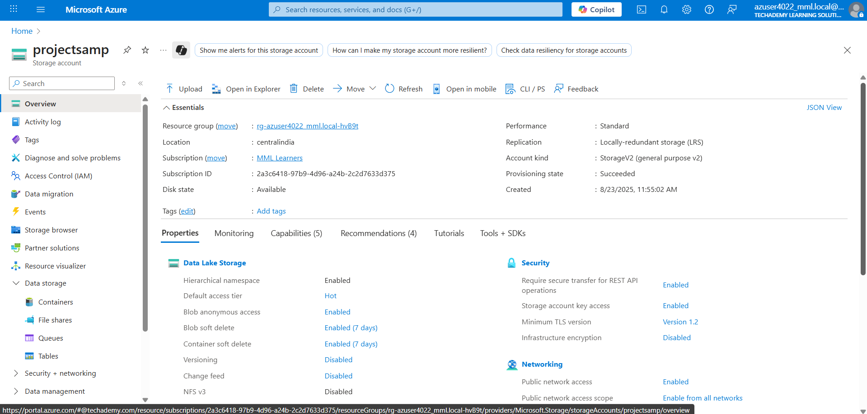

### Create two containers: sourcecontainer for CSV files, destinationparquetcontainer for converted Delta files.

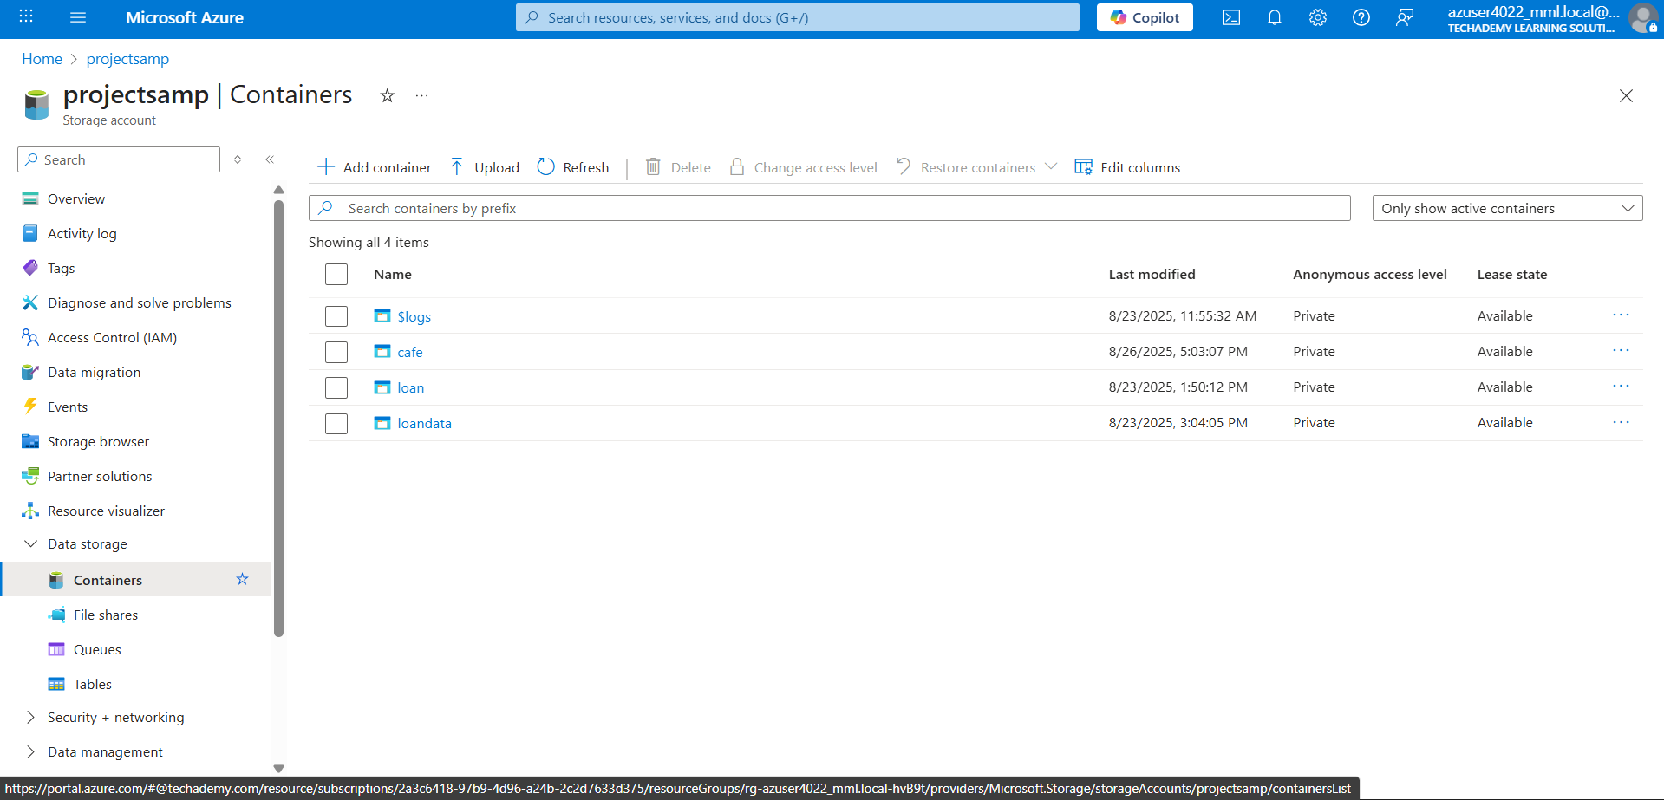

### Upload CSV files into the source container.

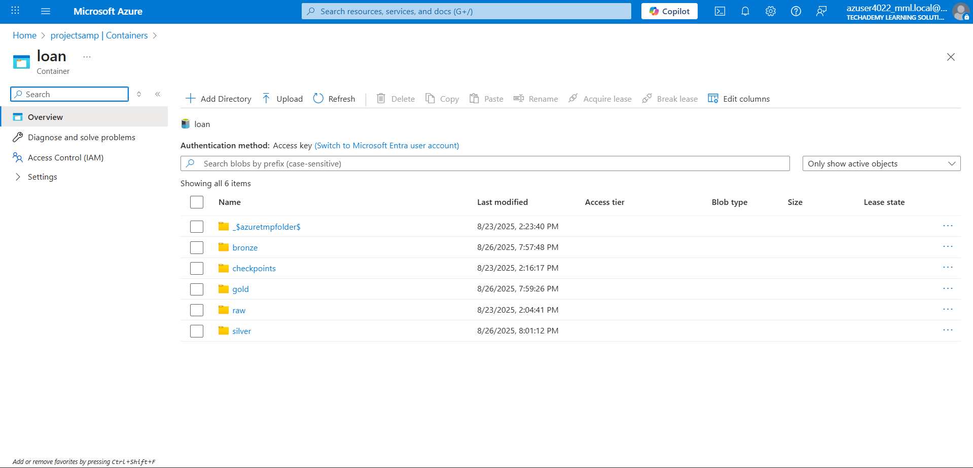

### **Step 2: Set Up Azure Databricks**

### Create a Databricks workspace and cluster in the Azure Portal.

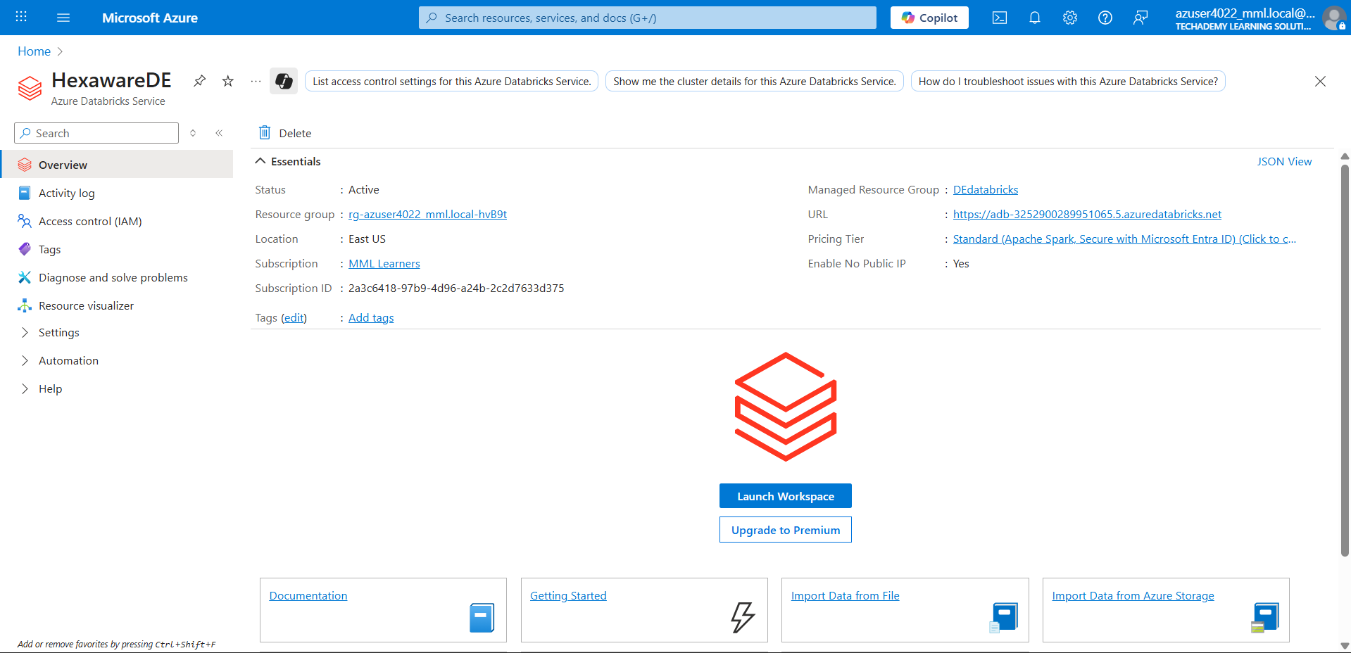

### Create a new Notebook to mount storage accounts and process files.

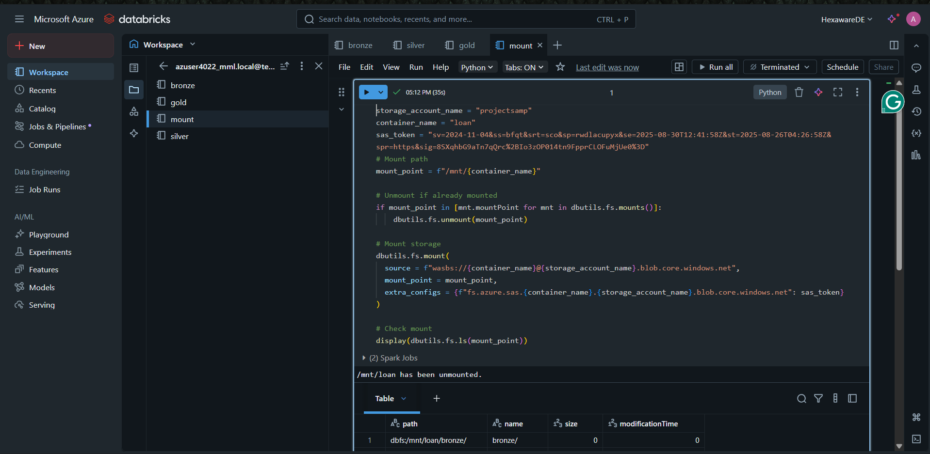

Create Bronze Notebook to copy the raw data

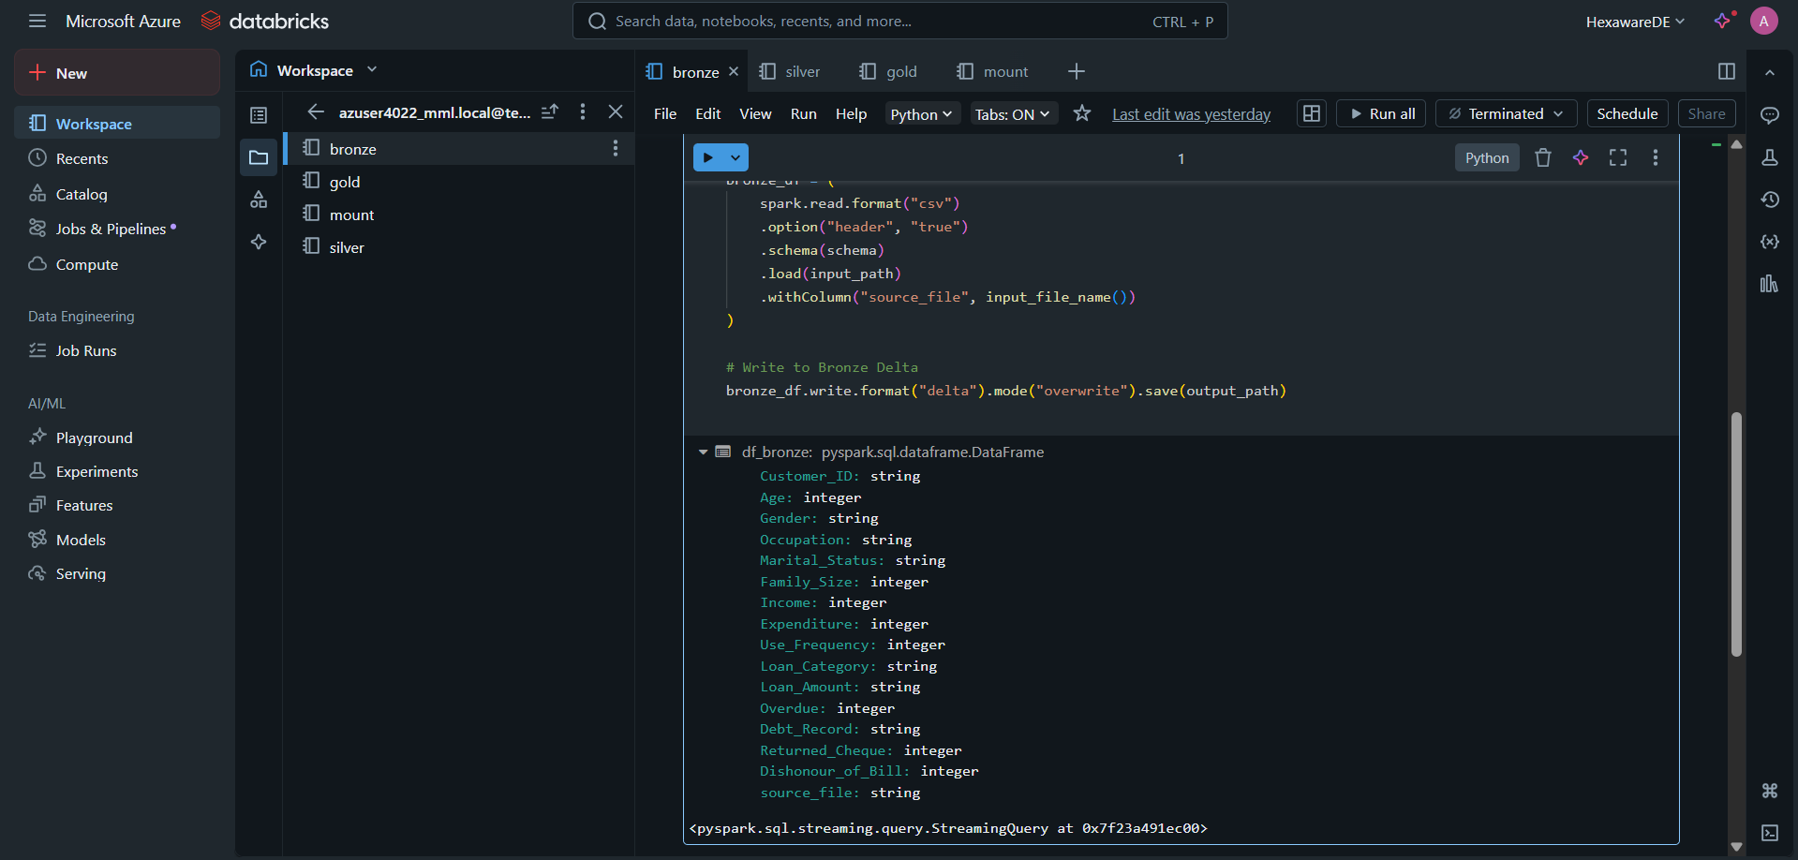

Create silver notebook to clean the data

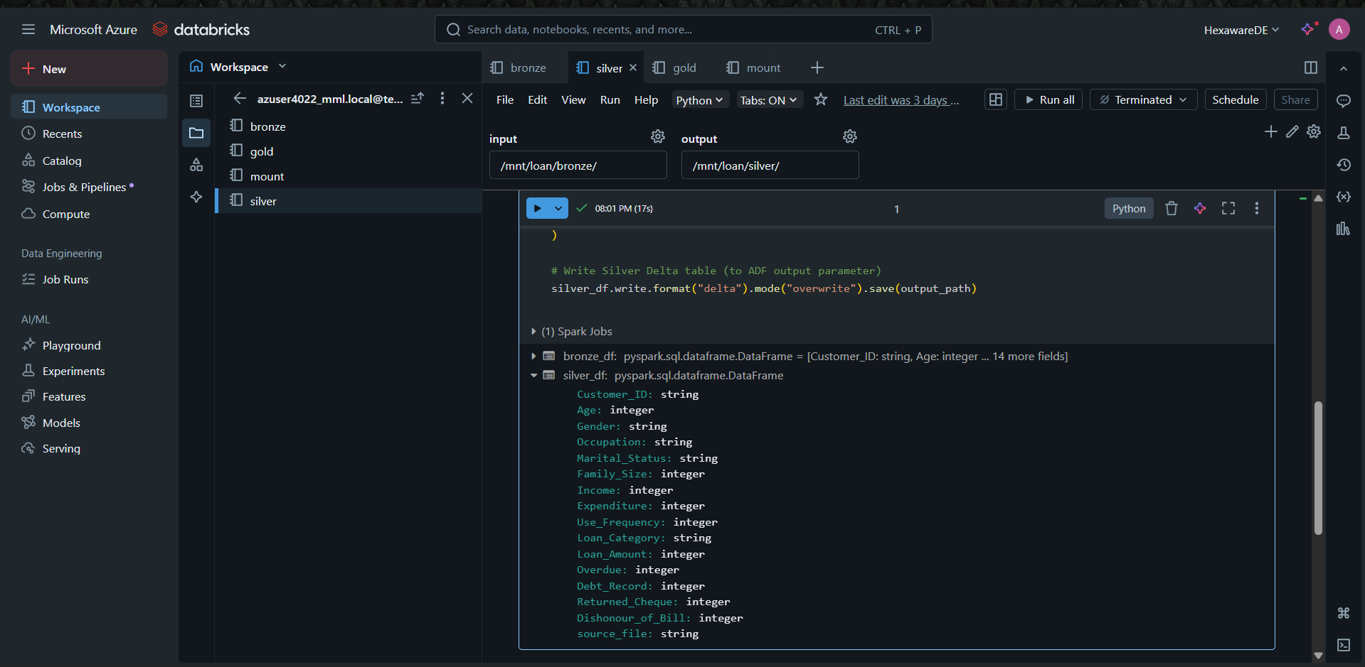

Create gold notebook for aggregation function

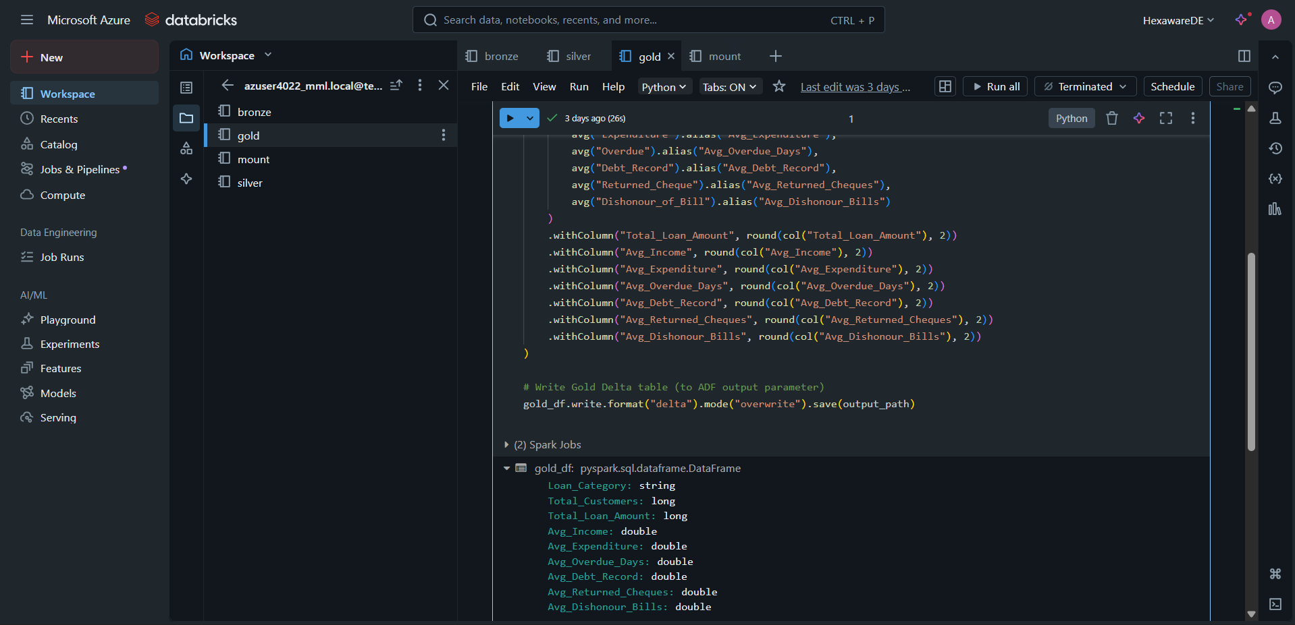

### **Step 3: Create a Data Factory**

### Launch Azure Data Factory Studio.

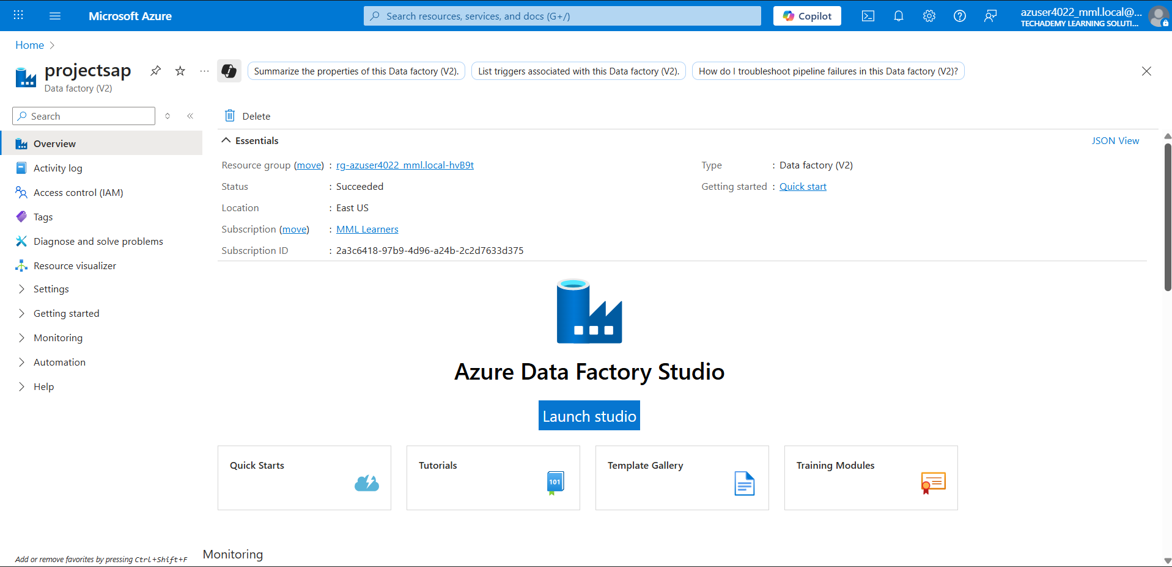

* Create an ADF pipeline with Databricks Notebook Activities.

**Step 4: Configure ADF Pipeline Activities**

* Define linked services for Azure Storage and Databricks.

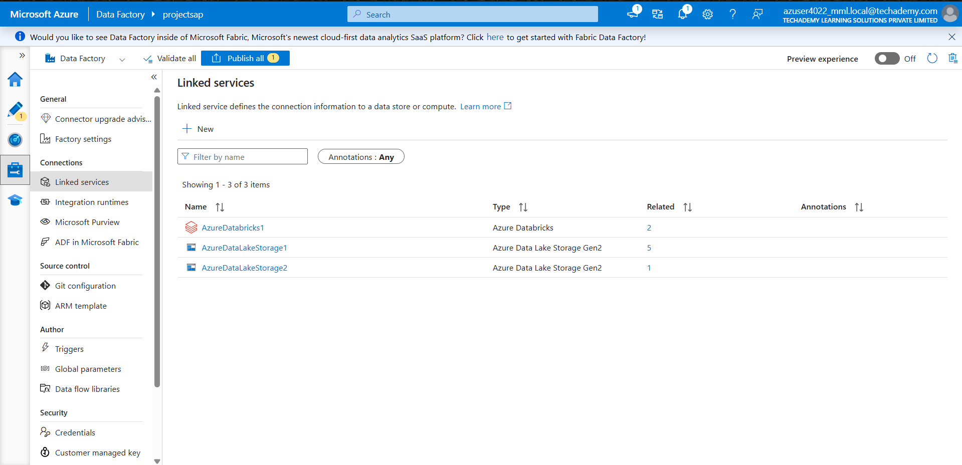

### Select the Databricks Notebook paths for Bronze, Silver, and Gold processing.

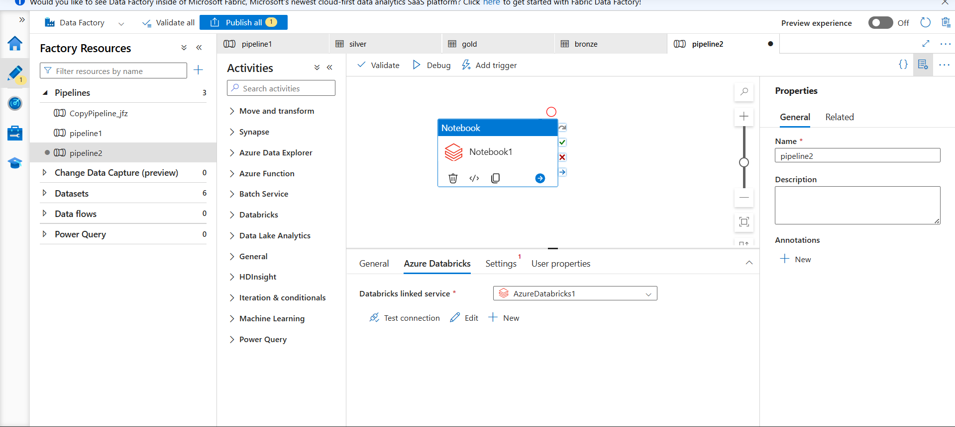

### Configure parameters for input/output paths.

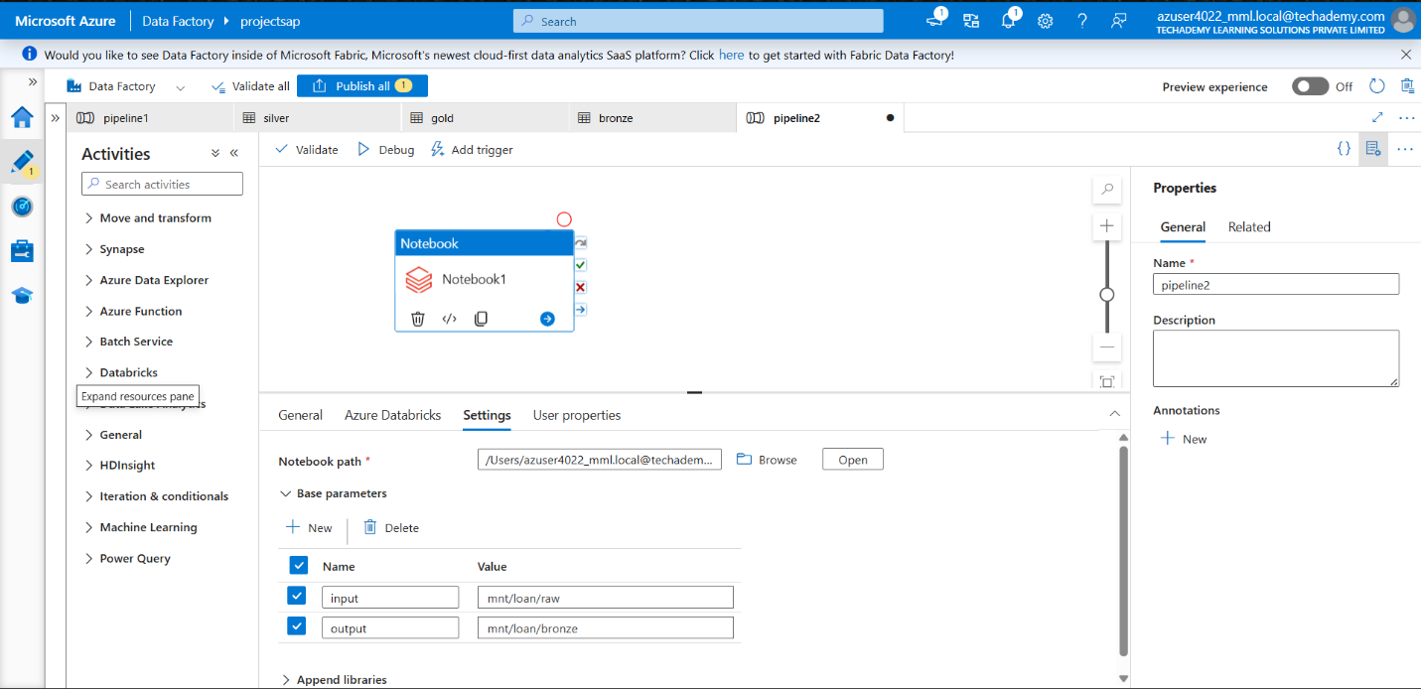

### Validate and debug pipeline to ensure success.

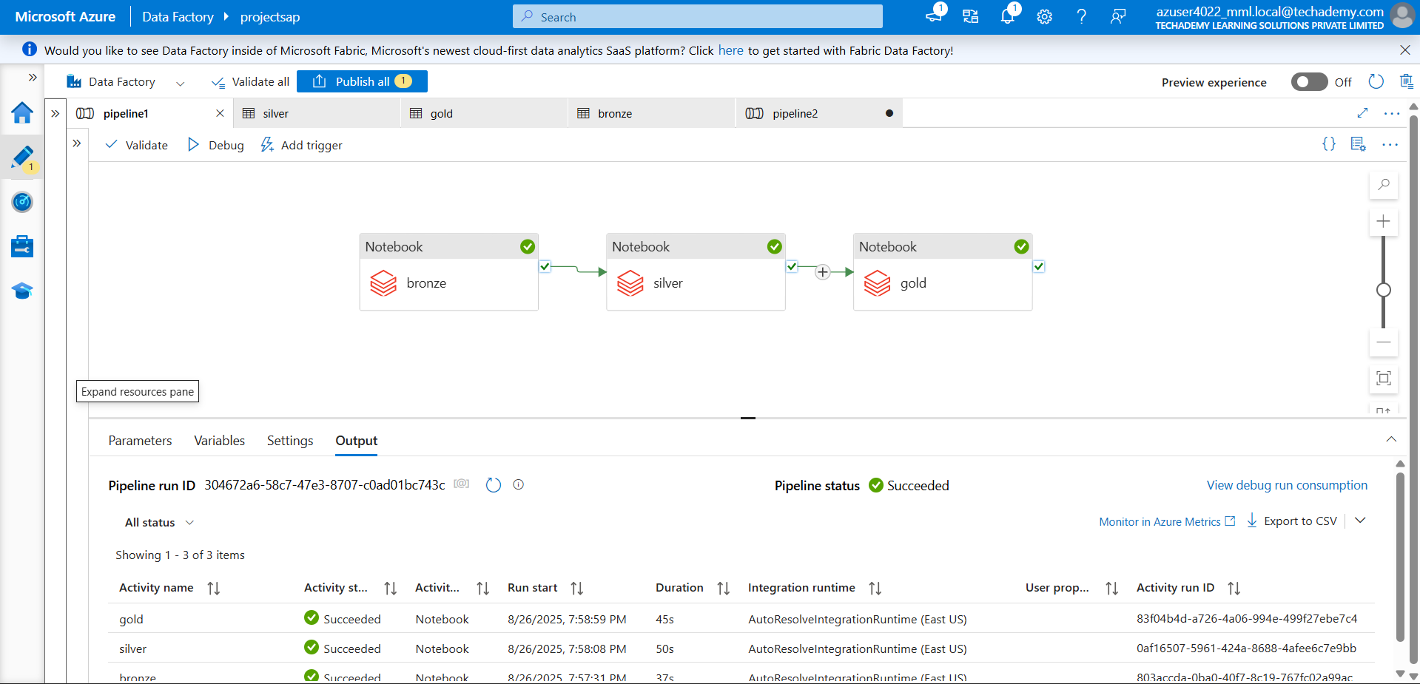

### Run the pipeline to copy CSV files and trigger Databricks notebooks.

### Check Delta folders in ADLS for Bronze, Silver, and Gold outputs.

**Step 5 : Set up Azure Devops**

### In the Git Repository, Store all Databricks notebooks, ADF pipeline JSON definitions, and configuration files.

* Add yaml file in the repository and set up the pipeline

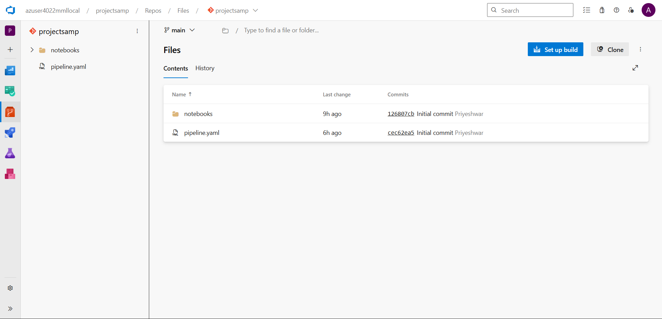

### **Step 6: Verify Data & Visualize**

### Open Power BI🡪get data source🡪Azure🡪Azure blob Storage

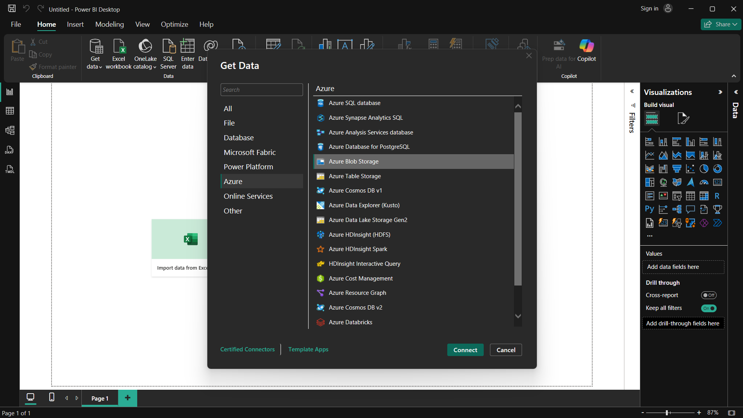

### Connect Power BI to Gold Delta tables for dashboards and analytics.

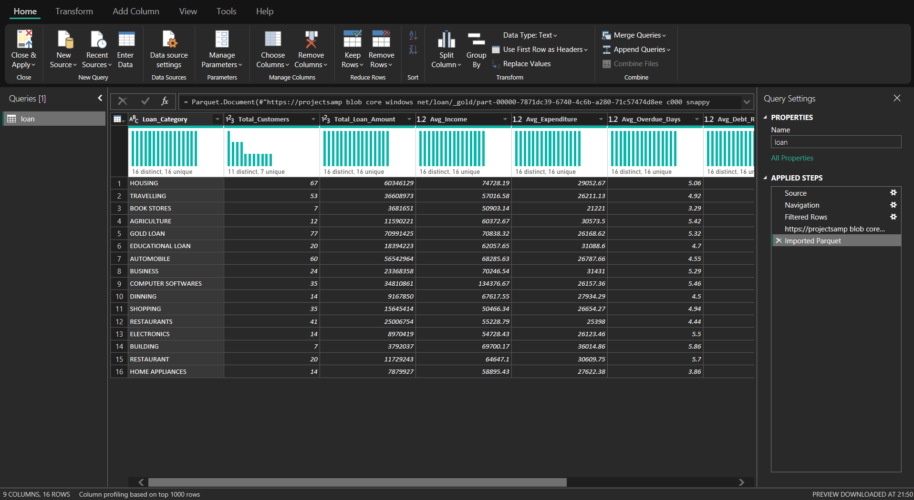

### Perform some analysis and create a report

**Successful Output Generated**

**1. Azure Data Factory (ADF) Pipeline Execution**

* After creating and configuring the pipeline with Databricks Notebook Activities, the pipeline was validated and debugged successfully.
* The pipeline execution status showed “Succeeded”, confirming that:
  + Raw CSV files from the source container were ingested into the Bronze Delta layer.
  + Transformations were applied, and data was written into Silver Delta tables.
  + Aggregated insights were generated in the Gold Delta tables.
* The ADF Monitoring dashboard displayed execution times, resource utilization, and confirmed that dependencies were executed in the correct order.



**2. Azure DevOps Pipeline Job**

* A CI/CD pipeline was created in Azure DevOps to automate deployment of:
  + Databricks notebooks (bronze.py, silver.py, gold.py)
  + Configuration files (parameters, mount scripts)

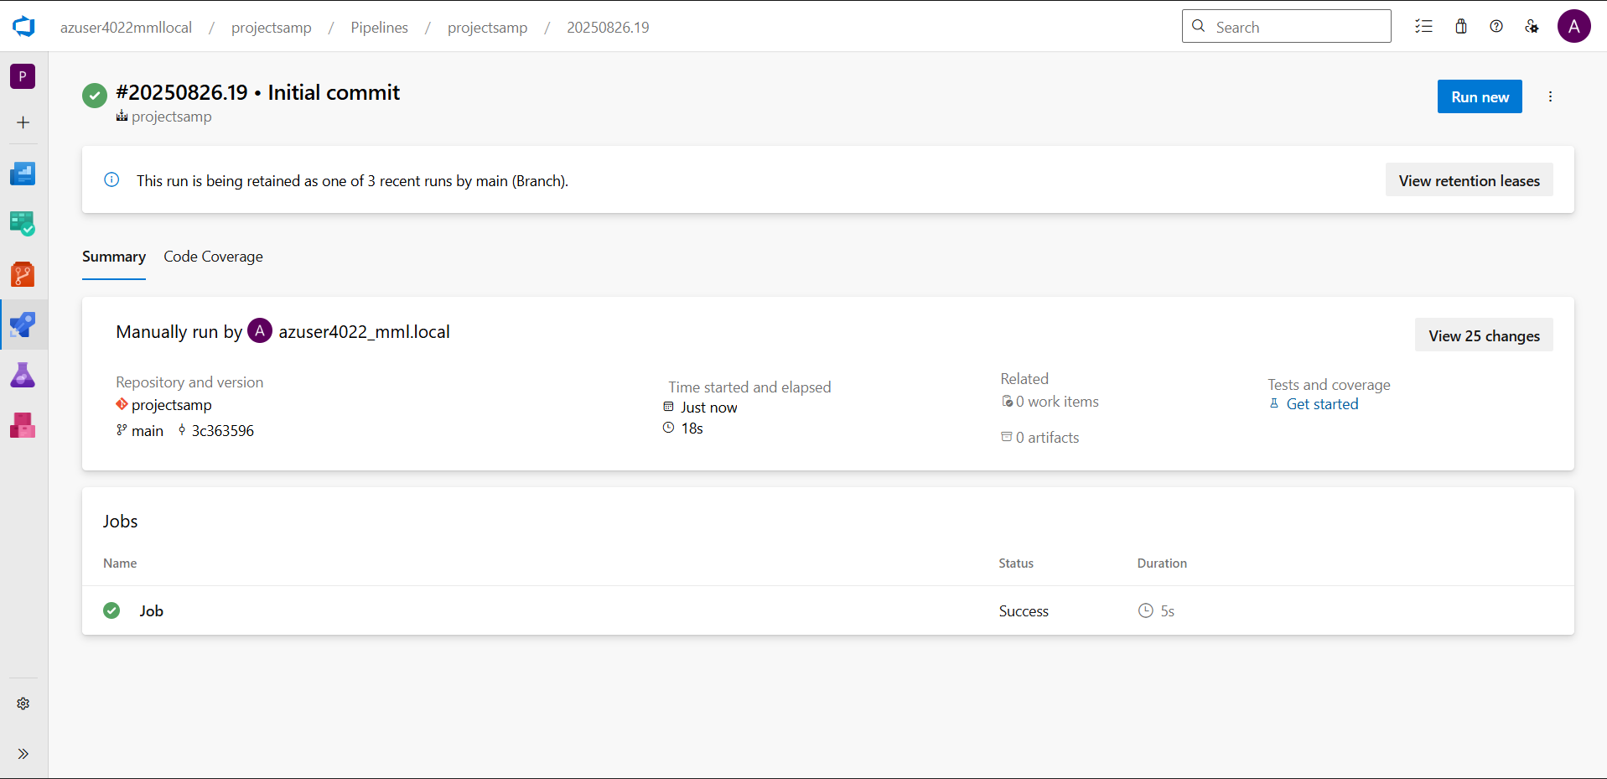

* The job status showed “Succeeded”, confirming that changes were deployed seamlessly without manual intervention.

**3. Power BI Visualization**

* Power BI was connected to the Gold Delta tables using Azure Synapse Analytics / Databricks SQL Endpoint.
* The dashboards showed clean, optimized data coming from the Delta Gold layer, validating that the end-to-end pipeline was functioning correctly.

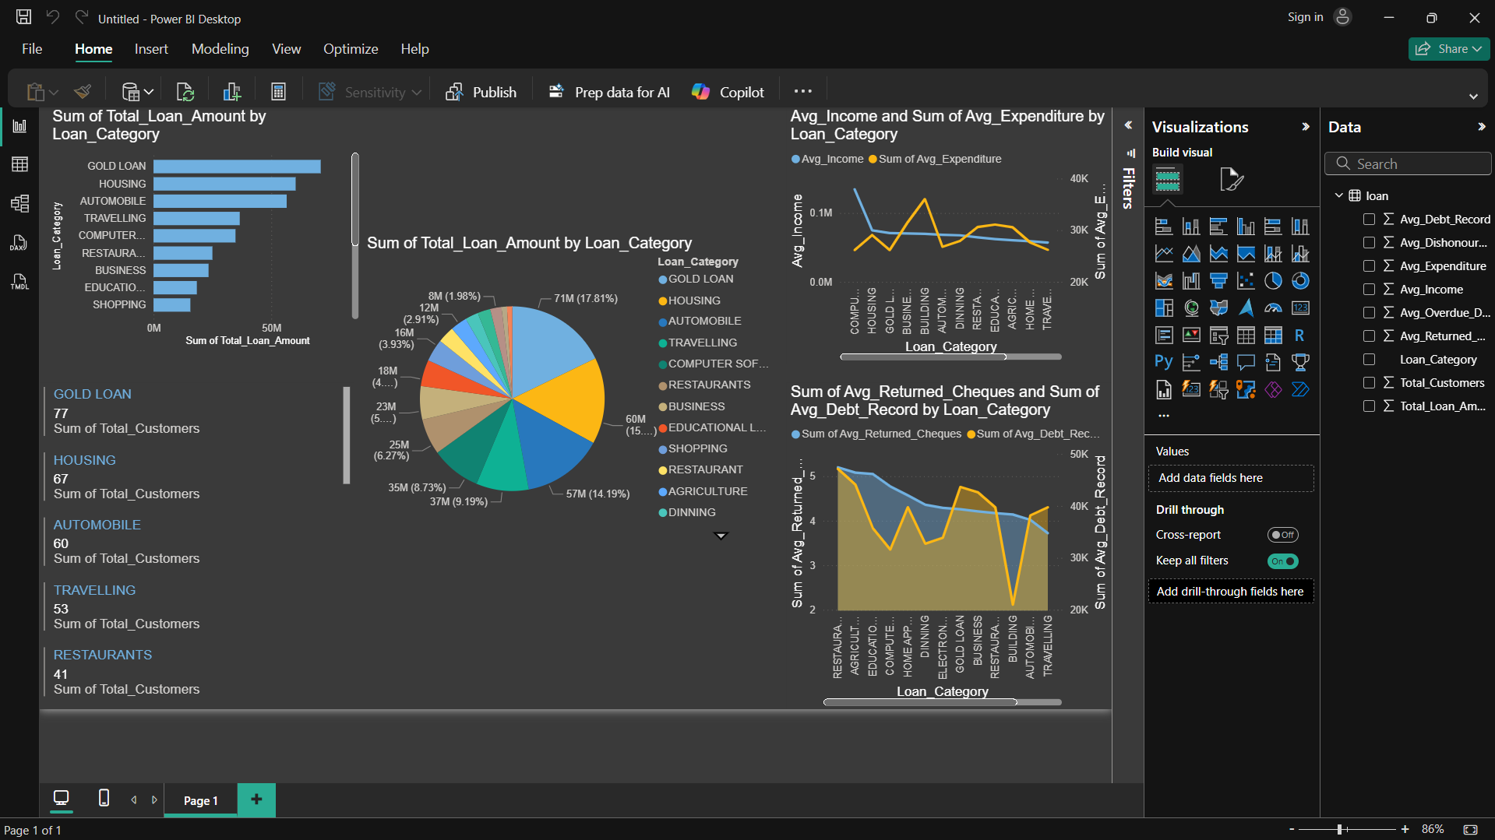

**Strategies for Optimizing Process**

1. **Data Cleaning and Transformation**
   * Handle missing or inconsistent values in the CSV/Delta tables.
   * Standardize column names and data types across Bronze, Silver, and Gold layers.
   * Apply trimming, type casting, and formatting only once to avoid redundant computations.
2. **Algorithmic Optimization**
   * Choose efficient Spark transformations and actions.
   * Avoid unnecessary joins or shuffles when aggregating Gold metrics.
3. **Data Structures Optimization**
   * Use Delta tables and partitioning to optimize read/write operations.
   * Store numeric fields in appropriate types (Integer, Double) to save memory.
4. **Parallelization**
   * Leverage Spark’s distributed processing to run transformations on multiple nodes.
   * Use parallel read/write operations where applicable.
5. **Caching**
   * Cache intermediate Silver datasets when multiple transformations are applied.
   * Reduce repeated disk reads for the same data.
6. **Code Profiling and Analysis**
   * Use Spark UI or Databricks Ganglia metrics to identify slow stages.
   * Optimize the longest-running transformations first.
7. **Vectorization**
   * Use PySpark built-in functions (col, withColumn, agg) for vectorized operations instead of Python loops.
8. **Memory Optimization**
   * Repartition data appropriately to avoid data skew.
   * Avoid keeping large intermediate datasets in memory unnecessarily.
9. **I/O Optimization**
   * Write Delta tables with partitioning and compression (e.g., snappy).
   * Minimize reading/writing CSV; use Delta format for faster performance.
10. **Concurrency and Multithreading**
    * Run multiple Databricks notebooks in parallel for different datasets.
11. **Batch Processing**
    * For historical loan data, process in batches to reduce cluster memory pressure.
    * Stream new files incrementally into Bronze and process in micro-batches.
12. **Distributed Computing**
    * Use the Databricks cluster’s full computing capacity for large loan datasets.
13. **Dynamic Resource Allocation**
    * Enable auto-scaling on the cluster to handle variable workloads efficiently.
14. **Checkpointing**
    * Use checkpoints for streaming or incremental processing to resume efficiently after failures.

**Conclusion**

This project successfully implemented a robust and scalable loan data processing pipeline using Azure Data Factory (ADF) and Azure Databricks, converting raw CSV files into optimized Delta tables stored in Azure Data Lake Storage (ADLS).

**Successful Implementation of the Data Pipeline**

* Azure Data Factory provided seamless orchestration of multiple stages, from ingesting raw CSV files to executing Databricks notebooks for data transformation.

### The pipeline ensured reliable scheduling and execution, supporting both batch and incremental data loads.

### **Efficient Data Transformation and Storage**

### Raw loan CSV data was ingested into the Bronze Delta layer, maintaining original data for traceability.

### Data cleaning and schema enforcement were applied in the Silver layer, resulting in structured and validated datasets.

### Aggregations and business metrics were computed in the Gold layer, supporting downstream analytics.

### **Exploration, Optimization, and Analytics Using Databricks**

### Databricks notebooks enabled interactive data exploration, validation, and transformation of the loan datasets.

### Optimization techniques such as partitioning, caching, vectorized operations, and checkpointing were applied to improve performance and reduce processing time.

### The pipeline supports near real-time analytics, enabling insights such as total loan amounts, average income, overdue trends, and returned cheque counts.

### **Integration and Reporting**

### The processed Gold-level data was made accessible to Power BI, allowing creation of dashboards for business insights and decision-making.

### Azure DevOps pipelines were used for CI/CD, ensuring version-controlled notebooks and reproducible deployments across environments.

### Overall, this project demonstrates a scalable, end-to-end solution for processing and analyzing loan data, leveraging the synergy between ADF, Databricks, ADLS, DevOps, and Power BI for effective data engineering and business intelligence.